Long Nguyen

000798286 (nd307)

BSc Computing

COMP1640 –Enterprise Web Software Development

Scrum Masters

Contents

Introduction 3

Functional Specifications 4

Database Design (ERD) 5

Site Design (Desktop) 7

Site Design (Mobile) 10

Test Plan (Progress Report) 11

# Introduction

* The aim of this coursework is to develop e_tutor system and the important point is that students will work in a team of 6-7 members. And members in team have their roles in the coursework. However, members can help each other in some particulars issues, such as designing user interface, using photoshop to create images, coding, etc.
* This report contains 4 parts:
* Functional Specifications
* Database design
* UI design with wireframe and site map for both desktop and mobile
* Test plan

|  |
| --- |
| **Scrum Masters** |
| Scrum Master – Matthew |
| Web Designer – Zarni |
| Programmer – Yang |
| Database – Long |
| Tester – Lesley |
| Product Owner – Satyajit Rai (Ashish) |

# Functional Specifications

1. Authorized Staffs

1.1. Allocate or reallocate personal tutor to each student (one by one or batch)

1.2. Sending the notification emails (only use for notification, no content)

1.3. Access to dashboard of each tutor and students

1.4. Support report generation

- Statistics (last 7 days messages, average number of messages for each personal tutor)

- Exception report (student have no personal tutor, student with no interaction for 7 days and 28 days)

1. Tutor
   1. Messaging
   2. Arrange the appointments
   3. Recording meeting
   4. Commenting the blog and uploaded work by students
   5. View can be sorted and filtered
2. Student
   1. Messaging
   2. Make appointments
   3. Uploading documents
   4. Comment
   5. Blog

# Database Design (ERD)

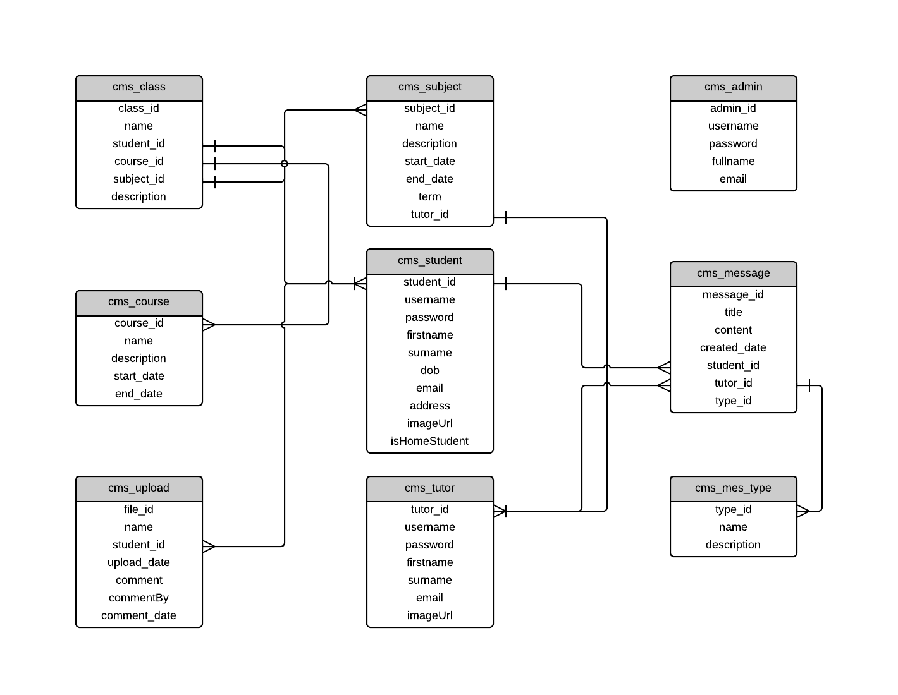

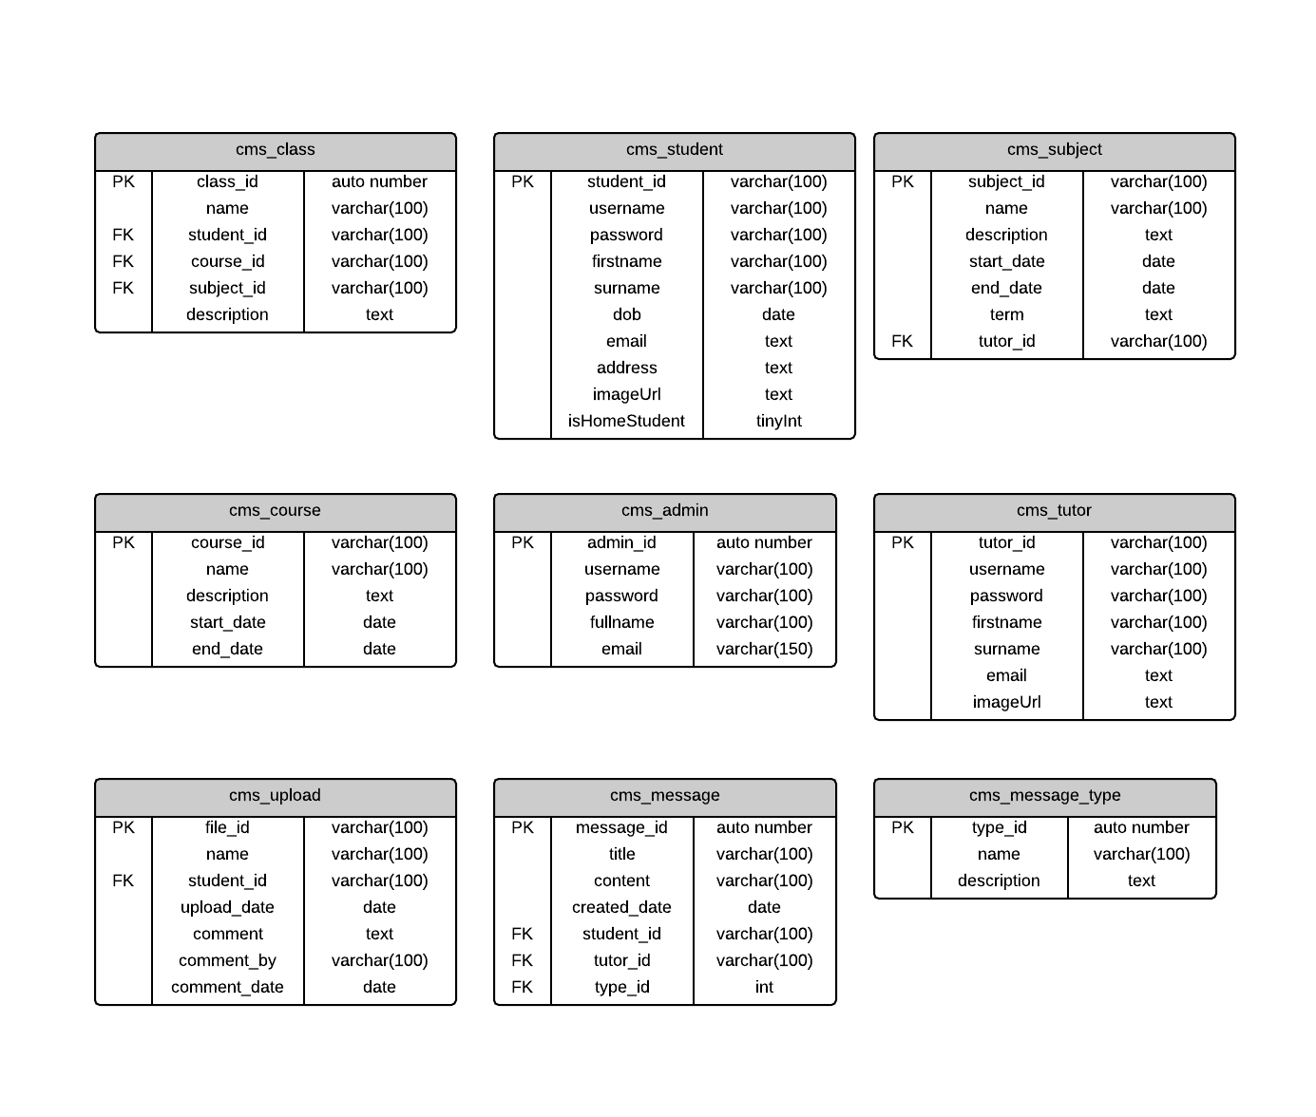

1. Design database

There are 9 tables in this database:

* cms_class
* cms_student
* cms_tutor
* cms_subject
* cms_course
* cms_upload
* cms_message
* cms_message_type
* cms_admin

1. How tables related to each other for the product

* cms_student: information of students and has student_id as Primary Key.
* cms_tutor: information of tutors and has tutor_id as Primary Key.
* cms_course: information of courses and has course_id as Primary Key.
* cms_admin: administrator’s information, has admin_id as Primary Key.
* cms_message_type: defines type of messages, has type_id as Primary Key.
* cms_subject: contains informations of subjects in courses, has subject_id as Primary Key and tutor_id as Foreign Key because each subject will have one personal tutor.
* cms_class: contains data of classes where students join in, has class_id as Primary Key, and student_id, course_id, subject_id as Foreign Key because there are many students in many classes with different subjects in different courses.
* cms_upload: contains information of work uploaded by student, has file_id as Primary Key, and student_id as Foreign Key.
* cms_message: contains information of messages, has message_id as Primary Key, and student_id, tutor_id, type_id as Foreign Key, so users will know who send or receive messages and what type of the message.

# Site Design (Desktop)

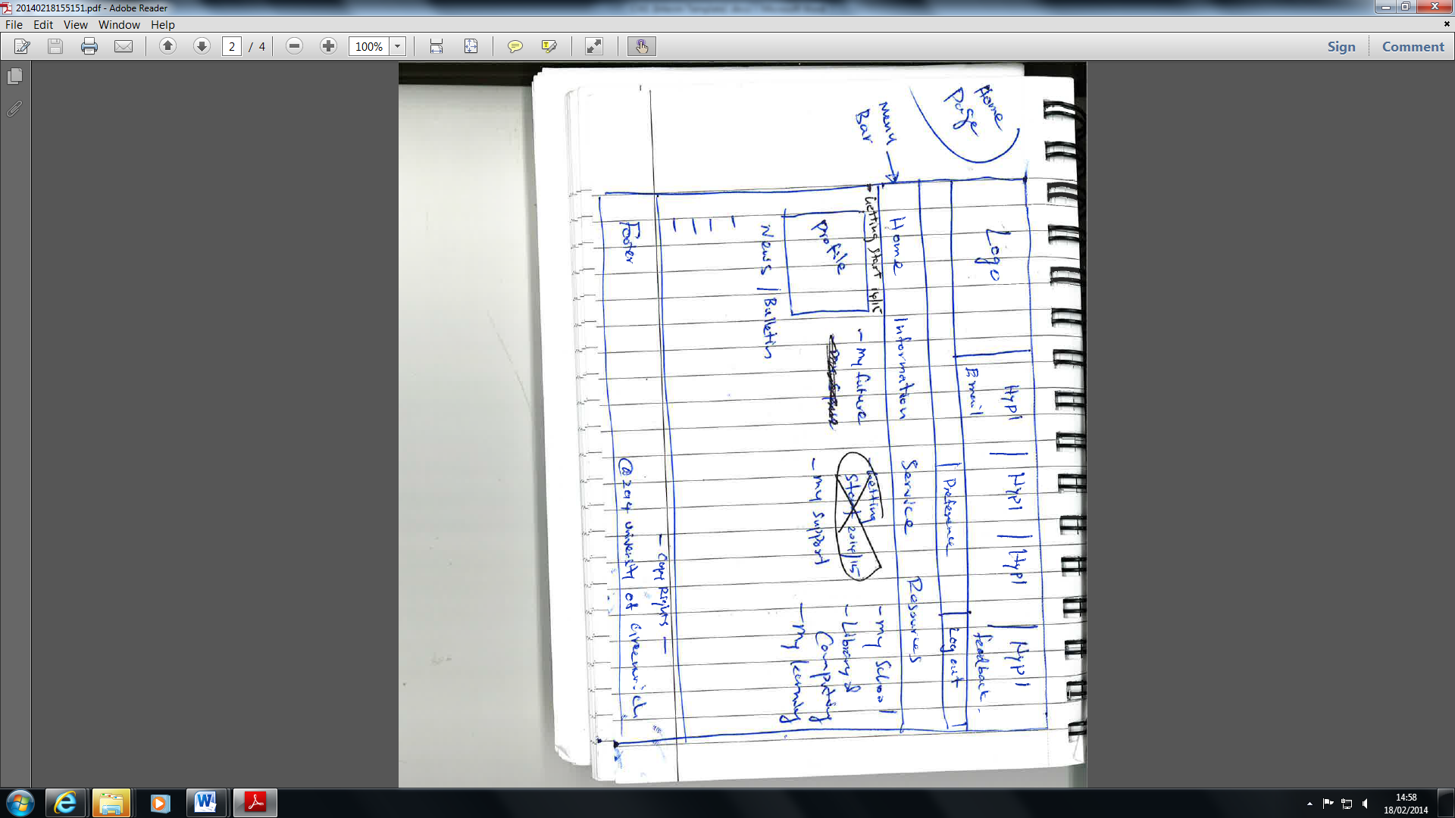

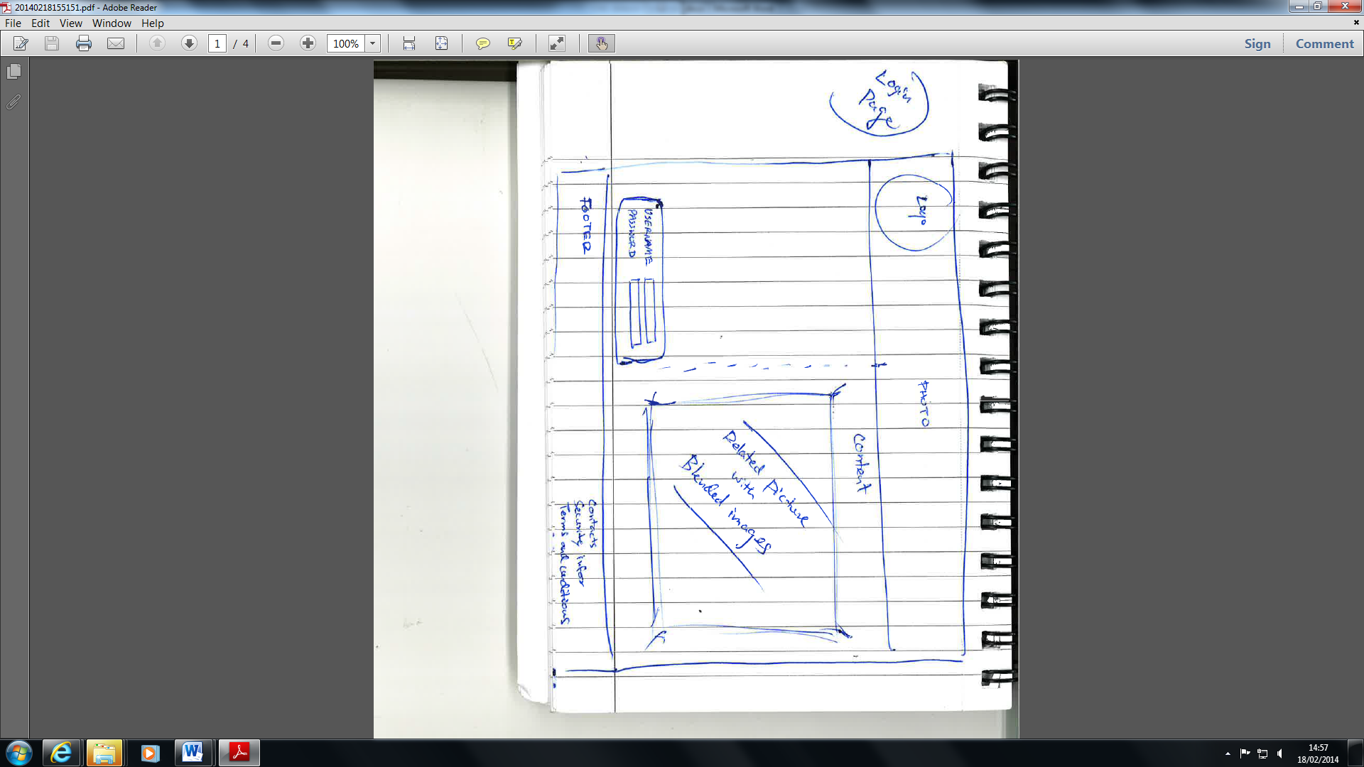 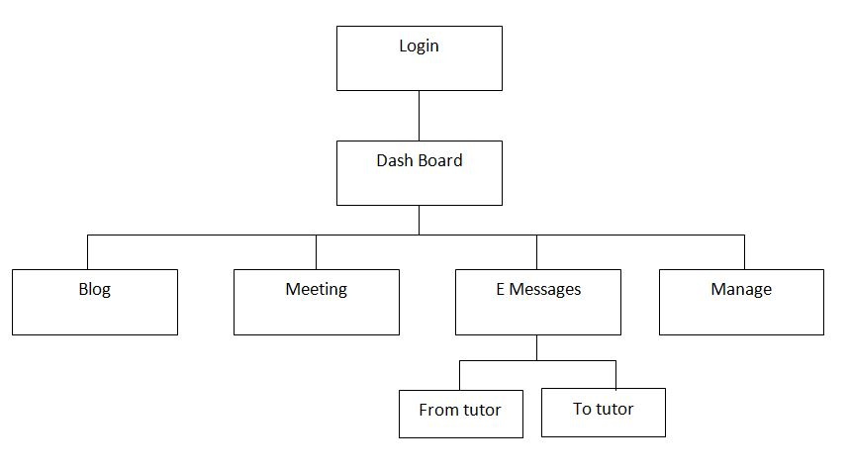

The system focus on functions of messaging for both tutors and students so in the dashboard of students, authorized staff and tutors will show all the messages, meeting requests and uploaded work of student.

* Authorized Staff: can see the statistics of system, allocate personal tutor for student, and send notifications.
* Tutor: can see all the courses and all students in their personal tutor groups, send messages and comment on uploaded work.
* Student: can see all mesasges, send messages to tutor, upload documents and see the comment on each uploaded work.

# Site Design (Mobile)

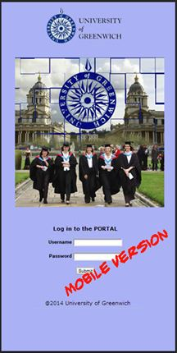

# Test Plan (Progress Report)

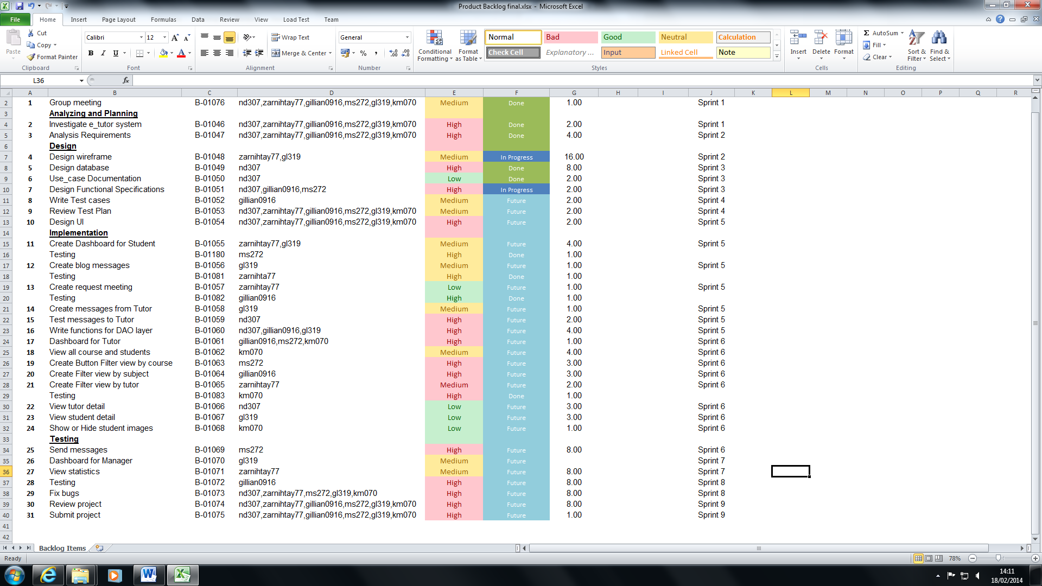

Testing Specification (Result Expected)

Dataset is numbered as Followed

1. Students must have personal Tutors

2. Authorised member of staff can allocate or reallocate personal tutors to students. Student and personal tutors will get notification emails when this happens.

3. Bulk Allocation of students to their personal tutor (e.g. 10 at a time) needs to be implemented

4. All students and their tutors are to use the eTutor system for messaging, Arranging and recording meetings (real and virtual), Uploading documents and commenting on them, and blogging.

5. Emails between students and their personal tutors is be used only for notification of events recorded in the backend database. No other content is to e sent via email.

6. Student and staff data is accessed from university MIS system. The Maintenance of this is outside the scope of their project.

7. Each Student will have own personal Dashboard summarising their interaction with their personal tutor.

8. Each personal tutor will have dashboard of their personal tutees that can be sorted and filtered appropriately.

9. Authorised staff to have access to dashboard of other staff, and individual dashboard for students.

10. Interface must be suitable for all devices (e.g. Mobile phones, tablets, desktops)

|  |  |  |  |  |
| --- | --- | --- | --- | --- |
| **Test** | **What is being tested** | **How** (All Student must log in to their account for the Testing to occur and they should possess of an Log In ID and a password) | **Test data Used** | **Expected Result** |
| **1** | Portal View | Logged in as a student- portal view | Dataset 1 | Log in students will be able to see their Personal Tutor |
| **2** | Administration System/ Email | ? | Dataset 2 | Student to have a personal tutor |
|  | Email | Portal-Click Email icon- type user Id and Password-view Notification | Dataset 2 | Notification in Email |
| **3** | Administration system | ? | Dataset 3 | Selected student to one tutor |
| **4** | MIS system | messaging, arranging, recording meetings | Dataset 4 | Record history |
|  | Uploading documents and commenting and blogging | View Dashboard- option will be visible | Dataset 4 | Uploading document and interacting with tutor |
| **5** | Email between students to their tutor to be used only for notification of event. No other content should be sent via email |  | Dataset 5 |  |
| **6** | MIS system | Log in as user and type password | Dataset 6 | Provide Information about University |
| **7** | Validation of eMessages | Portal-personal Tutorial- view Dashboard- click eMessages | Dataset 7 | All interaction with Tutor should be Showed |
| **8** | Each personal tutor will have dashboard for their personal tutees. | ? | Dataset 8 |  |
|  | Dashboard can be sorted and filtered |  | Dataset 8 |  |
| **9** | Authorised staff will have access to dashboard of other staff |  | Dataset 9 |  |
|  | Personal Tutorial Button | MIS system-Personal tutorial- view Dashboard | Dataset 9 | View Emessage and meeting |
| **10** | Mobile phones, tablets, desktops | View devices | Dataset 10 | View in mobile, tablets, desktops |

|  |  |  |  |
| --- | --- | --- | --- |
| **Dataset** | **Date Tested** | **Actual Result** | **Action Taken** |
| **1** | 2 Feb 2014 |  |  |
| **2** | 3 Feb 2014 |  |  |
| **3** | 5 Feb 2014 |  |  |
| **4** | 7 Feb 2014 |  |  |
| **5** | 8 Feb 2014 |  |  |
| **6** | 15 Feb 2014 |  |  |
| **7** | 18 Feb 2014 |  |  |
| **8** | 25 Feb 2014 |  |  |
| **9** | 1 Mar 2014 |  |  |
| **10** | 5 Mar 2014 |  |  |

The Following table has been set for users only to test the system function according to the specification and give Feedback. The following result was given out of 5.

|  |  |  |  |
| --- | --- | --- | --- |
| **Dataset** | **User 1** | **User 2** | **Feedback** |
| **1** |  |  |  |
| **2** |  |  |  |
| **3** |  |  |  |
| **4** |  |  |  |
| **5** |  |  |  |
| **6** |  |  |  |
| **7** |  |  |  |
| **8** |  |  |  |
| **9** |  |  |  |
| **10** |  |  |  |

Testing allows users to see the system from their perspective and find out what works well (so you can do it more) and can find out what isn't working AND WHY? Then fix it. You can test almost any aspect of the system. A real tester is a user rather than a developer since they can use according to their point knowledge.